

IOT ROBOT

MAJOR PROJECT REPORT

*By*

Vatsal shah

Roll No: IU1241090055

Department of Electronics & Communication Engineering

Indus Institute of Technology and Engineering

Ahmedabad

May 2016

**BONAFIDE CERTIFICATE**

This is to certify that this project report entitled **IOT ROBOT** submitted to **Department of Electronics and Communication Engineering, IITE, Ahmedabad**, is a bonafide record of work done by **VATSAL SHAH** under my supervision from

**January 1st, 2016** to **May 15th, 2016**.

………………………..

Abhishek Vaghela

Associate Professor

………………………..

R N Mutagi

Head of Department

Electronics & Communication Department

Place :

Date :

**Declaration by Author**

This is to declare that this report has been written by me. No part of the report is plagiarized from other sources. All information included from other sources have been duly acknowledged. I aver that if any part of the report is found to be plagiarized, I shall take full responsibility for it.

………………………..

VATSAL SHAH

IU1241090055

Place :

Date :

ABSTRACT

**TABLE OF CONTENTS**

**Particulars Page No. Page No.**

ABSTRACT 4

TABLE OF CONTENTS 5

LIST OF FIGURES 6

LIST OF TABLES 6

LIST OF ABBREVIATIONS 6

Ch-1 Introduction 8

Ch-2 Design Methodology 10

**2.1 Microcontoller: Arduino Mega 2560 10**

**2.2 Motor Driving IC L239D 11**

**2.3 DC Motor 12**

**2.4 Bluetooth (HC - 06) 12**

**2.5 IR Sensor 12**

**2.6 LDR Sensor 12**

**2.7 Ultrasonic Sensor 12**

**2.8 Real Time Clock 13**

**2.9 Vaccum Cleaning Mechanisam 13**

Ch-3 Application Software 14

Ch-4 Result and Analysis 15

Ch-5 Conclusion 15

References 15

# 

**LIST OF FIGURES**

|  |  |  |
| --- | --- | --- |
| **Figure No.** | **Figure Title** | **Page No.** |
| 2.1 | Block Diagram of system | 8 |
| 2.2 | A pulse width modulated waveform | 8 |
| 2.1.3 | Arduino Uno Front and Back | 9 |
| 2.1.1(A) | Pin configuration of L293D | 9 |
| 2.3 | Behaviours of motor for different input conditions | 9 |
| 3.1 | Screenshot of the Front Panel of our system | 11 |
| 3.2 | Screenshot of block Diagram of the system | 11 |
| 4.1 | Full Development System. | 12 |

# **LIST OF TABLES**

|  |  |  |
| --- | --- | --- |
| **Figure No.** | **Figure Title** | **Page No.** |
| I | Observation of the Motor According to DC MOTOR | 12 |
| 2.2.1(B) | Behaviours of motor for different input conditions | 9 |

**LIST OF ABBREVIATIONS**

|  |  |
| --- | --- |
| LabVIEW | Laboratory Virtual Instrument Engineering Workbench |
| PC | Personal Computer |
| VI | Virtual Instrument |
| NI | National Instrument |
| I/O | Input/output |
| USB | Universal Serial Bus |
| PWM | Pulse with Modulation |

**Ch-1 Introduction**

Raspberry Pi is a credit-card sized computer manufactured and designed in the United Kingdom by the Raspberry Pi foundation with the intention of teaching basic computer science to school students and every other person interested in computer hardware, programming and DIY-Do-it Yourself projects.

The Raspberry Pi is manufactured in three board configurations through licensed manufacturing deals with Newark element14 (Premier Farnell), RS Components and Egoman. These companies sell the Raspberry Pi online. Egoman produces a version for distribution solely in China and Taiwan, which can be distinguished from other Pis by their red coloring and lack of FCC/CE marks. The hardware is the same across all manufacturers.

The Raspberry Pi has a Broadcom BCM2835 system on a chip (SoC), which includes an ARM1176JZF-S 700 MHz processor, VideoCore IV GPU and was originally shipped with 256 megabytes of RAM, later upgraded (Model B & Model B+) to 512 MB. It does not include a built-in hard disk or solid-state drive, but it uses an SD card for booting and persistent storage, with the Model B+ using a MicroSD.

The Foundation provides Debian and Arch Linux ARM distributions for download. Tools are available for Python as the main programming language, with support for BBC BASIC (via the RISC OS image or the Brandy Basic clone for Linux), C, Java and Perl.

As of February 2014, about 2.5 million boards had been sold. The board is available online in India at a price of Rs. 3000.

In this section i.e. Chapter 1 we gave a brief introduction about how the vacuum cleaner will operate via a mobile application and automatically to make human life easy. In Chapter 2 we will discuss about the background details about the project which includes about the android platform, connectivity, dc motor, l298D motor shield and Arduino Mega board, Sensors, Vaccum Mechanisam, Dispay, Real Time clock. In Chapter 4 we will disucss about the Application Software part and in chapter 5 result and analysis.

**Ch-2 Design Methodology**

The design consists more on actual planning of hardware part than the code to be created. This section can be divided into many parts: raspberry pi, camera design, Motor control design

**Fig1.0 Block Diagram**

9

V

Raspberry

PI

Power

Supply

Motor

IC

Camera

Interface

WIFI

Adapter

Left

motor

Right

Motor

Figure 1. The initial block diagram for the Autonomous/Mannual Robotic Vacuum Cleaner

1. **Raspberry pi 2:**

The Micro SD card is used for installing OS and the complete project will be done with python coding. The board has specification:

* + - A 900MHz quad-core ARM Cortex-A7 CPU
    - 1GB RAM
    - 4 USB ports
    - 40 GPIO pins
    - Full HDMI port
    - Ethernet Port
    - Combined 3.5mm audio jack and composite video
    - Camera Interface
    - Display Interface
    - Micro SD card Slot
    - Video core IV 3D graphics core



Figure 2.1: Raspberry Pi B+ model.

1. **Camera design:**

Using a simple plug-in Raspberry Pi camera module, which will use for video streaming the output we can see on the web page that design for user. Since Raspberry Pi has a ready-to-use socket for camera cable, no extra cables or power supplies are needed.

1. **Motor control design:**

To control the motors, L293D motor control chip is used. Which is cheap and easily available. Design consisted of two motors. Design uses GPIO pins 17 and 18 to control the first motor and pins 22 and 23 to control the second motor. The 9V one battery will supply power for both of the motors, and Raspberry Pi will supply power for the motor control chips.

# Ch – 3 Hardware

## **3.1** **Hardware Layout:**

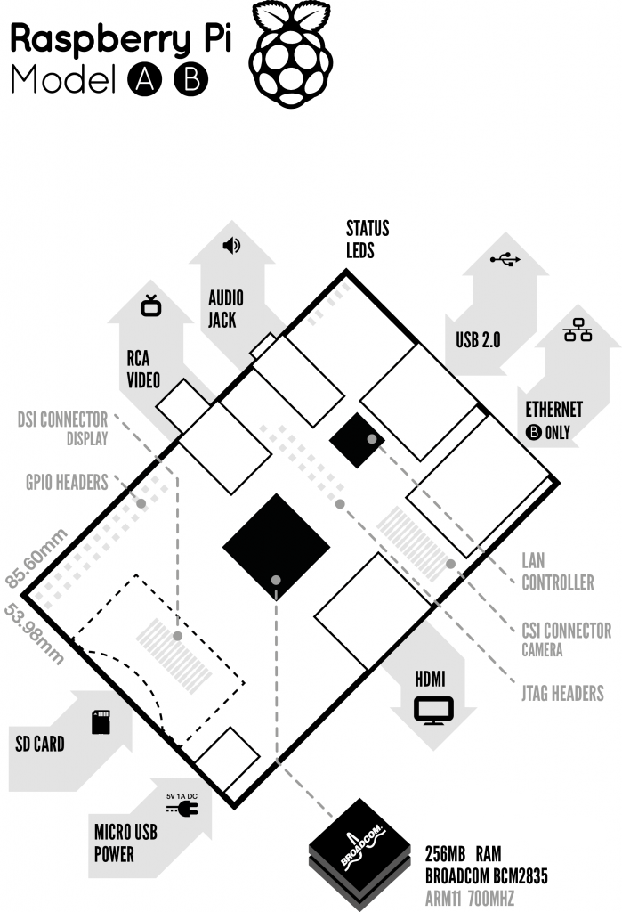

*Figure 5: Block Diagram of Raspberry Pi*

## **3.2 A brief description of the components on the Pi.**

1. Processor / SoC (System on Chip):

The Raspberry Pi has a Broadcom BCM2835 System on Chip module. It has a ARM1176JZF-S processor. The Broadcom SoC used in the Raspberry Pi is equivalent to a chip used in an old smartphone (Android or iPhone). While operating at 700 MHz by default, the Raspberry Pi provides a real world performance roughly equivalent to the 0.041 GFLOPS. On the CPU level the performance is similar to a 300 MHz Pentium II of 1997-1999, but the GPU, however, provides 1 Gpixel/s, 1.5 Gtexel/s or 24 GFLOPS of general purpose compute and the graphics capabilities of the Raspberry Pi are roughly equivalent to the level of performance of the Xbox of 2001. The Raspberry Pi chip operating at 700 MHz by default, will not become hot enough to need a heatsink or special cooling.

1. Power source

The Pi is a device which consumes 700mA or 3W or power. It is powered by a MicroUSB charger or the GPIO header. Any good smartphone charger will do the work of powering the Pi.

1. SD Card

The Raspberry Pi does not have any onboard storage available. The operating system is loaded on a SD card which is inserted on the SD card slot on the Raspberry Pi. The operating system can be loaded on the card using a card reader on any computer.

1. GPIO – General Purpose Input Output:

General-purpose input/output (GPIO) is a generic pin on an integrated circuit whose behaviour, including whether it is an input or output pin, can be controlled by the user at run time. GPIO pins have no special purpose defined, and go unused by default. The idea is that sometimes the system designer building a full system that uses the chip might find it useful to have a handful of additional digital control lines, and having these available from the chip can save the hassle of having to arrange additional circuitry to provide them.

GPIO capabilities may include:

* GPIO pins can be configured to be input or output
* GPIO pins can be enabled/disabled
* Input values are readable (typically high=1, low=0)
* Output values are writable/readable
* Input values can often be used as IRQs (typically for wakeup events)

The production Raspberry Pi board has a 26-pin 2.54 mm (100 mil) expansion header, marked as P1, arranged in a 2x13 strip. They provide 8 GPIO pins plus access to I²C, SPI, UART), as well as +3.3 V, +5 V and GND supply lines. Pin one is the pin in the first column and on the bottom row.

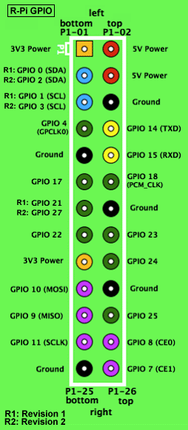

*Figure 6: GPIO connector on RPi*

1. DSI Connector:

The Display Serial Interface (DSI) is a specification by the Mobile Industry Processor Interface (MIPI) Alliance aimed at reducing the cost of display controllers in a mobile device. It is commonly targeted at LCD and similar display technologies. It defines a serial bus and a communication protocol between the host (source of the image data) and the device (destination of the image data). A DSI compatible LCD screen can be connected through the DSI connector, although it may require additional drivers to drive the display.

1. RCA Video:

RCA Video outputs (PAL and NTSC) are available on all models of Raspberry Pi. Any television or screen with a RCA jack can be connected with the RPi.

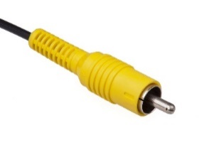

*Figure 7: RCA Video Connector*

1. Audio Jack

A standard 3.5 mm TRS connector is available on the RPi for stereo audio output. Any headphone or 3.5mm audio cable can be connected directly. Although this jack cannot be used for taking audio input, USB mics or USB sound cards can be used.

1. Status LEDs

There are 5 status LEDs on the RPi that show the status of various activities as follows:

“OK” - SDCard Access (via GPIO16) - labelled as "OK" on Model B Rev1.0 boards and "ACT" on Model B Rev2.0 and Model A boards

“POWER” - 3.3 V Power - labelled as "PWR" on all boards

“FDX” - Full Duplex (LAN) **(Model B)** - labelled as "FDX" on all boards

“LNK” - Link/Activity (LAN) **(Model B)** - labelled as "LNK" on all boards

“10M/100” - 10/100Mbit (LAN) **(Model B)** - labelled (incorrectly) as "10M" on Model B Rev1.0 boards and "100" on Model B Rev2.0 and Model A boards

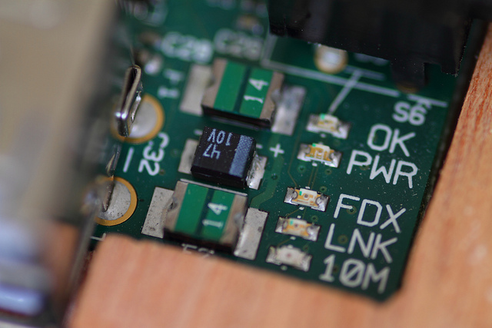

*Figure 8: Status LEDs*

1. USB 2.0 Port

USB 2.0 ports are the means to connect accessories such as mouse or keyboard to the Raspberry Pi. There is 1 port on Model A, 2 on Model B and 4 on Model B+. The number of ports can be increased by using an external powered USB hub which is available as a standard Pi accessory.

1. Ethernet

Ethernet port is available on Model B and B+. It can be connected to a network or internet using a standard LAN cable on the Ethernet port. The Ethernet ports are controlled by Microchip LAN9512 LAN controller chip.

1. CSI connector

CSI – Camera Serial Interface is a serial interface designed by MIPI (Mobile Industry Processor Interface) alliance aimed at interfacing digital cameras with a mobile processor.

The RPi foundation provides a camera specially made for the Pi which can be connected with the Pi using the CSI connector.

1. JTAG headers

JTAG is an acronym for ‘Joint Test Action Group', an organisation that started back in the mid 1980's to address test point access issues on PCB with surface mount devices. The organisation devised a method of access to device pins via a serial port that became known as the TAP (Test Access Port). In 1990 the method became a recognised international standard (IEEE Std 1149.1). Many thousands of devices now include this standardised port as a feature to allow test and design engineers to access pins.

1. HDMI – High Definition Multimedia Interface

HDMI 1.3 a type A port is provided on the RPi to connect with HDMI screens.

## **3.3 Specifications:**

|  |  |  |  |
| --- | --- | --- | --- |
|  | **Model A** | **Model B** | **Model B+** |
| **Target price:** | US$25 | US$35 | |
| **SoC:** | Broadcom BCM2835 (CPU, GPU, DSP, SDRAM, and single USB port) | | |
| **CPU:** | 700 MHz ARM1176JZF-S core (ARM11 family, ARMv6 instruction set) | | |
| **GPU:** | Broadcom VideoCore IV @ 250 MHz | | |
| **Memory (SDRAM):** | 256 MB (shared with GPU) | 512 MB (shared with GPU) as of 15 October 2012 | |
| **USB 2.0 ports:** | 1 (direct from BCM2835 chip) | 2 (via the on-board 3-port USB hub) | 4 (via the on-board 5-port USB hub) |
| **Video input:** | 15-pin MIPI camera interface (CSI) connector, used with the Raspberry Pi Camera Addon. | | |
| **Video outputs:** | Composite RCA (PAL and NTSC) –in model B+ via 4-pole 3.5 mm jack, HDMI (rev 1.3 & 1.4), raw LCD Panels via DS | | |
| **Audio outputs:** | 3.5 mm jack, HDMI, and, as of revision 2 boards, I²S audio (also potentially for audio input) | | |
| **Onboard storage:** | SD / MMC / SDIO card slot (3.3 V card power support only) | | MicroSD |
| **Onboard network:** | None | 10/100 Mbit/s Ethernet (8P8C) USB adapter on the third/fifth port of the USB hub | |
| **Low-level peripherals:** | 8× GPIO, UART, I²C bus, SPI bus with two chip selects, I²S audio +3.3 V, +5 V, ground | | 17× GPIO |
| **Power ratings:** | 300 mA (1.5 W) | 700 mA (3.5 W) | 600 mA (3.0 W) |
| **Power source:** | 5 V via MicroUSB or GPIO header | | |
| **Size:** | 85.60 mm × 56 mm (3.370 in × 2.205 in) – not including protruding connectors | | |
| **Weight:** | 45 g (1.6 oz) | | |

*Table 1 Specifications*

## **3.4 Brief description of System on Chip (SoC):**

Since smartphones and tablets are basically smaller computers, they require pretty much the same components we see in desktops and laptops in order to offer us all the amazing things they can do (apps, music and video playing, 3D gaming support, advanced wireless features, etc).

But smartphones and tablets do not offer the same amount of internal space as desktops and laptops for the various components needed such as the logic board, the processor, the RAM, the graphics card, and others. That means these internal parts need to be as small as possible, so that device manufacturers can use the remaining space to fit the device with a long-lasting battery life.

Thanks to the wonders of miniaturization, SoC manufacturers, like Qualcomm, Nvidia or Texas Instruments, can place some of those components on a single chip, the System on a Chip that powers smartphones.

A system on a chip or system on chip (SoC or SOC) is an integrated circuit (IC) that integrates all components of a computer or other electronic system into a single chip. It may contain digital, analog, mixed-signal, and often radio-frequency functions—all on a single chip substrate. SoCs are very common in the mobile electronics market because of their low power consumption. A typical application is in the area of embedded systems.

The contrast with a microcontroller is one of degree. Microcontrollers typically have under 100 kB of RAM (often just a few kilobytes) and often really are single-chip-systems, whereas the term SoC is typically used for more powerful processors, capable of running software such as the desktop versions of Windows and Linux, which need external memory chips (flash, RAM) to be useful, and which are used with various external peripherals. In short, for larger systems, the term system on a chip is a hyperbole, indicating technical direction more than reality: increasing chip integration to reduce manufacturing costs and to enable smaller systems. Many interesting systems are too complex to fit on just one chip built with a process optimized for just one of the system's tasks.

A typical SoC consists of:

* A microcontroller, microprocessor or DSP core(s). Some SoCs—called *multiprocessor system on chip* (MPSoC)—include more than one processor core.
* memory blocks including a selection of ROM, RAM, EEPROM and flash memory
* timing sources including oscillators and phase-locked loops
* peripherals including counter-timers, real-time timers and power-on reset generators
* external interfaces, including industry standards such as USB, FireWire, Ethernet, USART, SPI
* analog interfaces including ADCs and DACs
* voltage regulators and power management circuits
* A bus - either proprietary or industry-standard such as the AMBA bus from ARM Holdings - connects these blocks. DMA controllers route data directly between external interfaces and memory, bypassing the processor core and thereby increasing the data throughput of the SoC.

## 

## **3.5 Accessories:**

Raspberry Pi being a very cheap computer has attracted millions of users around the world. Thus it has a large user base. Many enthusiasts have created accessories and peripherals for the Raspberry Pi. This range from USB hubs, motor controllers to temperature sensors. There are some official accessories for the RPi as follows:

**Camera** – On 14 May 2013, the foundation and the distributors RS Components & Premier Farnell/Element 14 launched the Raspberry Pi camera board with a firmware update to support it. The Raspberry Pi camera board contains a 5 MPixel sensor, and connects via a ribbon cable to the CSI connector on the Raspberry Pi. In Raspbian support can be enabled by the installing or upgrading to the latest version of the OS and then running Raspi-config and selecting the camera option. The cost of the camera module is 20 EUR in Europe (9 September 2013). and supports 1080p, 720p, 640x480p video. The footprint dimensions are 25 mm x 20 mm x 9 mm.

**Gertboard** – A Raspberry Pi Foundation sanctioned device designed for educational purposes, and expands the Raspberry Pi's GPIO pins to allow interface with and control of LEDs, switches, analog signals, sensors and other devices. It also includes an optional Arduino compatible controller to interface with the Pi. The Gertboard can be used to control motors, switches etc. for robotic projects.

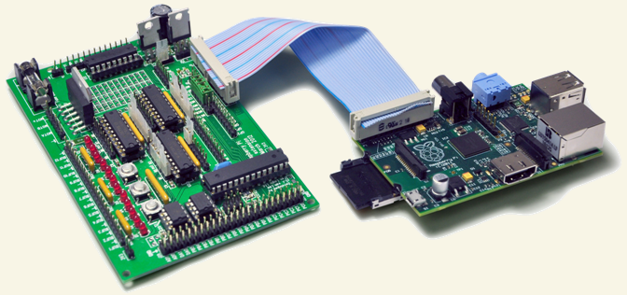

*Figure 9: Gertboard (left) & Raspberry Pi(Right)*

**USB Hub** – Although not an official accessory, it is a highly recommended accessory for the Pi. A powered USB Hub with 7 extra ports is available at almost all online stores. It is compulsory to use a USB Hub to connect external hard disks or other accessories that draw power from the USB ports, as the Pi cannot give power to them.

## 6.3 Comparison of Raspberry with the competitors

The chief competitors of the Raspberry Pi are the Arduino and the Beagleboard. Both are single board computers and have applications similar to the Raspberry Pi. A brief comparison of the three of them is shown below:

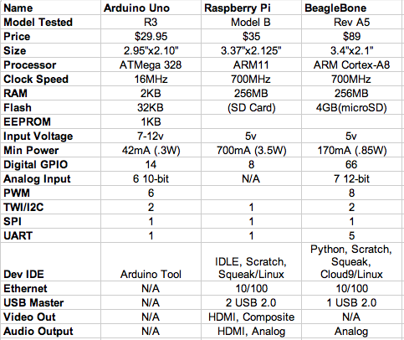

*Figure 17: Comparison of RPi with chief competitors*

## 6.4 Advantages and disadvantages

Advantages of the Raspberry Pi:

It is important for customers and business owners that want to get the Raspberry Pi to consider whether it fits with their business strategy and are willing to go through the process of putting it together and tailoring the product to their own needs. The benefits that this products offers beside the low price point are:

* This microcomputer is useful for small or home based businesses that run on a smaller budget than bigger companies for you are not required to purchase any special licenses from the Raspberry Pi Foundation to use their product or if you invent new technology that embeds the product. Small business owners can use it to automate any small task, such as using the Pi to run a website ( as long as it does not have a lot of traffic), or use it as a small database and media server... pretty much anything that doesn't require the Windows operating system or other systems that does not support Linux and lots of traffic). Businesses can also save money on buying cooling systems that are required to cool servers.
* The product does not require the user to have extensive programming experience since it is aimed for the younger generation to learn about programming. Python, the programming language that the Pi uses, is less complex than other languages available. For example, it has better code readability and allows the user to type concepts using fewer amount of lines. Python also has an automatic memory management function.
* The product also gives you a lot of room to experiment and turn it into something else that is entirely different.  The SD cards on the board can be easily switched, which allows you to change the functions of the device without spending a lot of time re-installing the software.
* The Raspberry Pi is perfect for adaptive technology: it is able to display images or play videos at 1080p high definition resolution to building systems such as digital jukeboxes or prototyping embedded systems. This product makes it possible to build complex and effective products at a cheaper price.
* The product is energy efficient and provides a greener ethical alternative to small businesses. This small credit card sized product makes it easy to recycle and does not release as much carbon dioxide emissions into the environment, unlike big servers that require lots of energy and extensive cooling systems.

Disadvantages:

* It does not replace your computer, since the Ethernet is only a 10/100 and the processor is not as fast, it is time consuming to download and install software and is unable to do any complex multitasking.
* Not compatible with other operating systems such as Windows (There are currently 1.3 billion Windows users around the world.)
* To use the Raspberry Pi,it will take more than just 35 dollars to get it to do what you need through buying extra accessories such as the SD card, USB power supply, keyboard..etc and if you take into account the acquisition cost of the product. This is only fit for those who want a gadget that they can tailor to their own needs and tastes, not for those who just wants to get a job done fast. Business owners need to consider if the extra hassle is worth it.
* This product will not be useful for bigger businesses that already have big servers, which would already do everything that the Raspberry Pi does, so it would not be worth it to take the time to get someone to put it together.

**Ch-4 Application Software**

The Android app is generally developed using JAVA language. The app controlling this vacuum robot can be built without having the knowledge in java language. It is called as “VBot211” developed by MIT App Inventor. Shown below is a diagram which shows the interface of the app. The app shown below has 5 buttons and all the button gives 5 different bytes in the output that is to be fed to the microcontroller to further process. For e.g. if we press Up! Button, the Bluetooth module will give 1 byte at its output.

The app invented by these searches for the Bluetooth devices along with their MAC addresses. The user just needs to select a particular MAC Address. When a particular MAC is selected, the status shown on the screen is “Connected”. Now all the buttons are active and the app is now connected with the robot and mobile phone can control the robot, like shown below.

**Ch-4 Work Done & Results**

The aim of this project is to design and develop a Autonomous and Android Application based Vaccum Cleaning Robot.

**Ch-5 Future Work**

The current research work illustrates the design and development of a LabVIEW based speed and direction

**Ch-6 Conclusion**

# **References**

[1] History of embedded devices, http://www.discussionsworld.com/forum_posts.asp?TID=42603

[2] About Raspberry Pi, http://www.raspberrypi.org/about/

[3] Early prototype of Raspberry Pi, http://www.raspberrypi.org/raspberry-pi-2006-edition/

[4] Raspberry Pi Hardware information, http://elinux.org/RPi_Hardware

[5] How SoC works, http://www.androidauthority.com/how-it-works-systems-on-a-chip-soc-93587/

[6] Boot process, http://thekandyancode.wordpress.com/2013/09/21/how-the-raspberry-pi-boots-up/

[7] NOOBS, http://www.raspberrypi.org/introducing-noobs/

[8] List of available OS, http://elinux.org/RPi_Distributions

[9] Home automation project, http://www.instructables.com/id/Raspberry-Pi-GPIO-home-automation

[10] Arcade gaming machine project, http://www.cnet.com/how-to/25-fun-things-to-do-with-a-raspberry-pi/

[11] Robot project, http://www.wired.com/2013/01/raspberry-pi-r2d2/

[12] Landline telephone project, https://www.twilio.com/blog/2013/03/build-a-twilio-hard-phone-with-sip-from-twilio-raspberry-pi-asterisk-freepbx-and-the-obihai-obi100.html

[13] Decoration lights project, http://www.element14.com/community/community/raspberry-pi/raspberrypi_projects/blog/2013/12/12/raspberry-pi-enabled-christmas-lights

[14] Advantages-Disadvantages, https://sites.google.com/site/mis237groupprojectraspberrypi/home/what-is-raspberry-pi/pros-and-cons-of-the-raspberry-pi